NJ Emissions Data: Comparing Gas Powered Cars and Electric Powered Cars

Group #7

Stephanie Contino - [contins1@tcnj.edu](mailto:contins1@tcnj.edu)

Ayesha Chaudhry - [chaudha1@tcnj.edu](mailto:chaudha1@tcnj.edu)

Srujana Endreddy - [endreds2@tcnj.edu](mailto:endreds2@tcnj.edu)

Geethika Manojkumar - [manojkg1@tcnj.edu](mailto:manojkg1@tcnj.edu)

Andrew Varlese - [varlesea@tcnj.edu](mailto:varlesea1@tcnj.edu)

**Phase I:**

<https://drive.google.com/file/d/1KcN1NReRE0bqiRDN8XOtsfQI_-wI8hZB/view?usp=sharing>

**Phase lI:**

With the growing concern of climate change, many people are wondering which steps can be taken to reduce the issue. Greenhouse gasses are one of the biggest contributors to climate change. Commonly, greenhouse gasses are emitted from gas powered vehicles. The issue of greenhouse gas emissions from vehicles has been persistent for many years. According to the EPA, 4.6 metric tons of carbon dioxide are emitted annually from a typical passenger vehicle (Environmental Protection Agency, 2022). This number can be eliminated by switching to alternatively fueled cars. Our project is focusing on electric vehicles as an alternative to gas powered cars. Electric vehicles emit no tailpipe emissions (Environmental Protection Agency, 2022). We believe making the switch to electric vehicles from gas powered vehicles will greatly reduce the amount of greenhouse gas emissions released into the atmosphere and increase sustainability.

Stakeholders will be constantly affected by the transition from gas to electric vehicles, for example, the utilities will be affected by the increase in demand for electricity to power EVs, which could put pressure on the electric grid. However, integrating smart charging systems and renewable energy sources can help mitigate this issue. Additionally, utilities may have an opportunity to provide charging infrastructure for EVs, creating a new source of revenue. Another stakeholder that will be heavily affected by EVs is the automakers themself. The production of EVs requires a significant investment in research, development, and changes to the manufacturing process. As EVs become more popular, automakers may shift their focus to producing more sustainable vehicles to remain competitive. Additionally, the sale of EVs can be affected by government policies and regulations, such as emissions standards and tax incentives.

There are ethical concerns regarding electric vehicles. Though they are much better for the environment in terms of emissions, there are concerns over how the battery supplies are gathered. Cobalt mining is especially one of the main concerns. According to Forbes, “The U.S. Department of Labor estimates that at least 25,000 children are working in cobalt mines in the DRC, a number that is sure to grow as the production of climate-friendly electric cars expands” (Posner, 2023). With this in mind, it is important to solve the ethical concerns of electric vehicles before making a full transition from gas powered vehicles. Overall, gas powered vehicles are hurting the environment and present a large issue of sustainability, but we must also be careful to not create a new problem.

To further understand the role of vehicles emitting greenhouse gas emissions, data collected from Sustainable Jersey elucidates that on-road vehicles in every municipality of New Jersey produce the highest amount of greenhouse gas emissions as compared to other pollutants (Sustainable Jersey, 2022). Since many individuals depend on their automobiles as their primary mode of transportation, on-road vehicles thus account for the majority of gas emissions. In 2020 alone 82% of residents in New Jersey used cars, trucks, or vans as their means of transportation to work (Sustainable Jersey, 2022). As a result, the data displays that among all the New Jersey townships, automobiles contribute the most carbon dioxide to the atmosphere (Sustainable Jersey, 2022). Furthermore, data gathered from different road textures will also be implemented into the database to demonstrate how it affects the municipalities’ greenhouse gas emissions in various localities. Most importantly, the database will also include the data of an increase in electric vehicle ownership in all municipalities of New Jersey.

Several questions arose within the data we collected regarding greenhouse gas emissions between gas cars vs electric cars in New Jersey. First and foremost being comparing both vehicles (gas and electric), which released the most and least amount of emissions. Which municipalities had the least amount of greenhouse gas emissions, and what mode of transportation was common for that area. The data following those research questions would help further prove the relation between vehicles and those specific municipalities gas emissions. Another research question being how does gas car emissions compare to electric vehicle charging. And finally, how does certain road textures for municipalities play a role in lessening the amount of greenhouse gas emissions within that area.

This data can help identify sustainability problems by showing numbers of greenhouse gas emissions by county, municipality, and statewide. It would help bring into perspective the total amount of emissions. By then examining the data from just gas powered vehicles, it would help further show that there is a large issue of sustainability with gas powered vehicles. The data of vehicle miles traveled is also supportive in showing this sustainability problem. With this data, the opportunity to propose change is evident. Seeing how many emissions are produced leads into the question of what can be done to reduce them. By showing how emissions and total output compares by making the switch to electric vehicles, this data will show that it is possible to make vehicles more sustainable by switching from gasoline to electric.

Use case I: Add a map to the website

Primary Actor: User

Goal in Context: Add a map of New Jersey’s municipalities to display data for which municipality emits high amounts of greenhouse gas emissions.

Trigger: User decides to view the map data on the website

Scenario:

1. User clicks on “map data” and hovers over the map
2. User clicks on a specific municipality on the map to view data
3. Based on mouse hover, data of that municipality will be displayed.

Use case II: Interactive Pie chart

Primary actor: User

Goal in Context: Add a pie chart that shows each municipality and their respective community GHG emissions by sector and energy type. An interactive button will be provided that’ll allow users to be able to change municipalities and view whatever data for any municipality they choose.

Trigger: User decides to view data based on different municipalities

Scenario:

1. User clicks on “show chart”.
2. User clicks on button to switch between municipalities
3. Pie chart will continuously alter to the next municipality data based on interactive button being switched.

**Phase III:**

ER diagram:

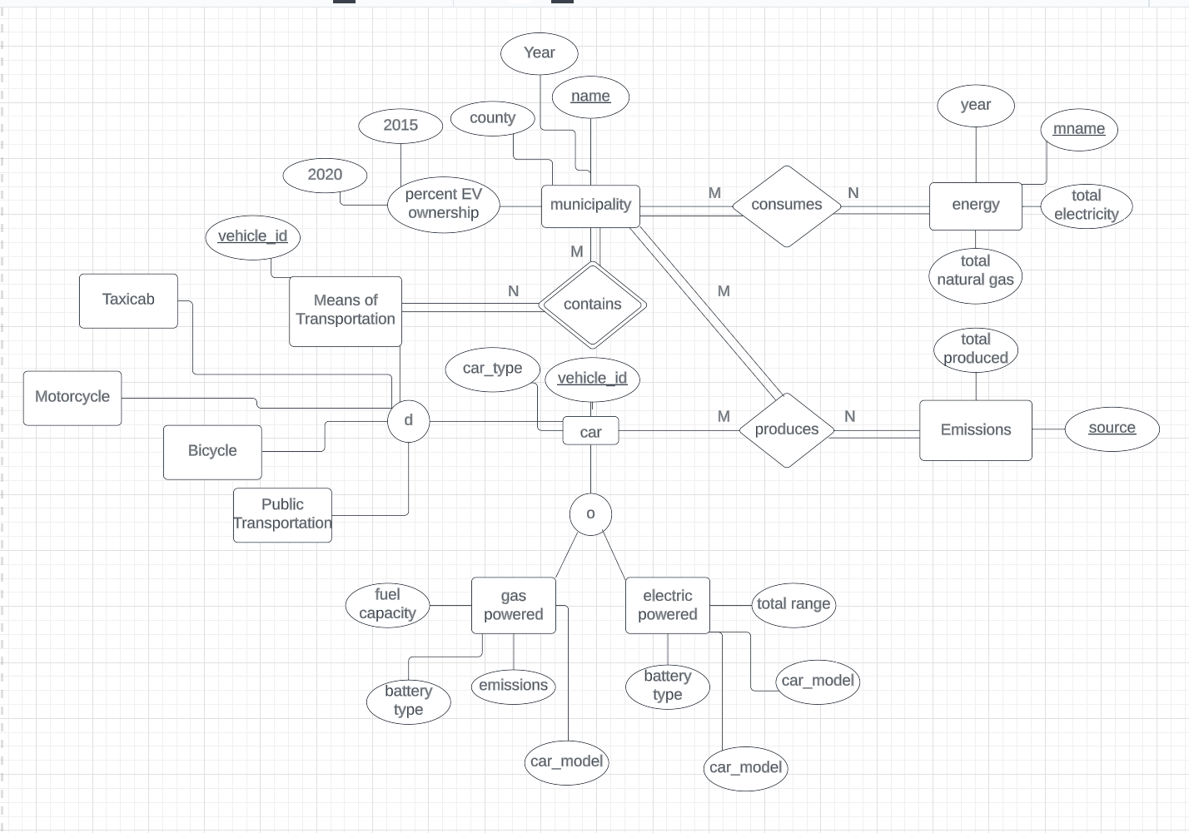

Schema:

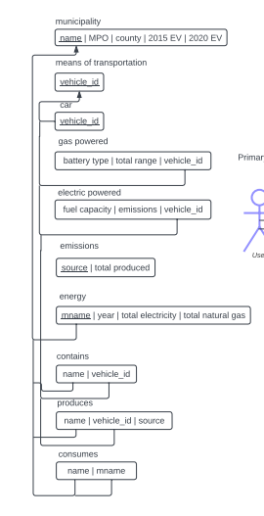

UML Use Case Diagram:

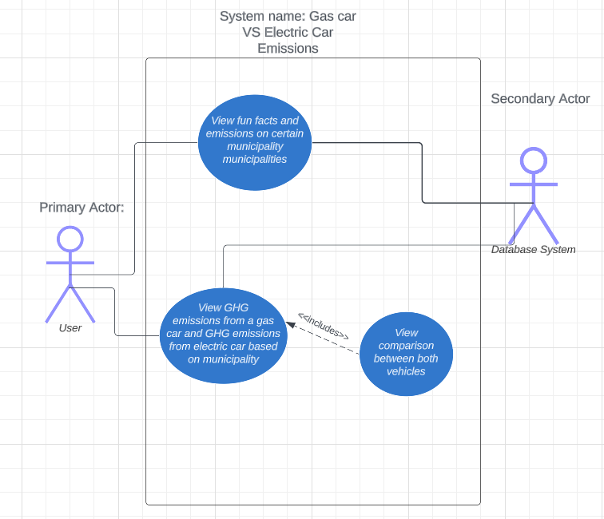

**Database Model Explained:**

Relational databases organize data into rows and columns specifying attributes and relationships of entities. Entities are things in the world, attributes are traits about those entities, and relationships are how entities are connected. Relational databases are valuable because they explain how different entities are connected and organize information in an easy to read, tabular form. Our diagram contains 4 main entities- municipality, means of transportation, energy, and emissions. Means of transportation contains subclasses taxicab, motorcycle, bicycle, public transportation, and car. Car is also broken down into the gas powered and electric powered subclasses. Our diagram shows the relationship between vehicles and emissions, as well as municipalities and energy consumption. Our database model focuses on these relationships and how emissions compare from different modes of transportation, with a heavy focus on cars. We designed the database in this way because our goals involve finding ways to reduce emissions and encourage people to switch to vehicles with less emissions. We are also looking for ways to reduce energy consumption, because that also contributes to emissions. We want to encourage sustainability by giving users different ways of looking at how energy and vehicles impact emissions. Here are the calculations to estimate the rough size of our database.

File name: Vehicle_Miles_Traveled-On-Road_Vehicle_GHG_Emissions_Data_08.11.22

* This is the VMT Data Section
* Municipality: assuming that max string strength is 20 chars * 1 byte = 20 bytes
* County name: assuming that max string length is 15 chars * 1 byte = 15 bytes
* MPO: the string length is 5 = 5 chars * 1 byte = 5 bytes
* Year: integer type so 4 bytes
* The columns after Year includes all integer types: 14 * 4 bytes = 56 bytes
* Total number of entries in the excel sheet: 1129 entries (this doesn't include the row for the column name and info): 1129
* The rough size is: 1129 * (20 + 15 + 5 + 4 + 56) = 112,900 bytes

File name: Community-Scale_GHG_Emissions_08.22.2

* This is the Community-Scale_GHG_Emissions - Metric Ton Carbon Dioxide Equivalent
* Municipality: assuming that max string strength is 20 chars * 1 byte = 20 bytes
* County name: assuming that max string length is 15 chars * 1 byte = 15 bytes
* Year: integer type so 4 bytes
* The columns after Year includes all integer types: 11 * 4 bytes = 44 bytes
* The total number of entries in the excel sheet (this doesn't include the row for the column name and info): 1129
* The rough size is: 1129 * (20 + 15 + 4 + 44) = 93, 707 bytes

File name: Electric_Vehicle_Ownership_Data_06.01.22

* This is Electric Vehicle (EV) Ownership Data
* Municipality: assuming that max string strength is 20 chars * 1 byte = 20 bytes
* County name: assuming that max string length is 15 chars * 1 byte = 15 bytes
* Year: integer type so 4 bytes
* Total personal vehicles: can be integer type so 4 bytes
* # of Evs: can be integer type so 4 bytes
* % of Evs: can be integer type so 4 bytes
* The rough size is: 1129 * (20 + 14 + 4 + 4+ 4 + 4) = 57, 579 bytes
* The total size of the database is: 112,900 + 93,707 + 57,579 bytes = 264, 186 bytes

The estimated average number of searches is approximately 70 searches and the type of databases are numerical and string.

Use case I: Add a map to the website

Primary Actor: User

Goal in Context: Add a map of NJ and the user can press a certain municipality and it will link to another page that shows that area's facts and emission release/data specific to that area.

Trigger: User decides to view the map data on the website

Scenario:

1. User hovers over the map of New Jersey

2. User clicks on a specific municipality on the map to view data

3. User is transported to a new website that holds that areas emission data.

Use case II: Car feature button

Primary Actor: User

Goal in Context: Adding two separate car shaped buttons (electric and gas) that’ll show how much gas emissions a gas car will release within the municipality (drop down bar) and how much an electric car releases.

Trigger: User decides to view how much emissions both cars release within the same area.

Scenario:

1. User chooses an municipality from the drop down bar

2. User presses on whichever car icon they prefer (electric vs gas)

3. User is shown data that’ll depict the emissions of whichever car they choose.

**Appendix for Phase III:**

ER diagram: 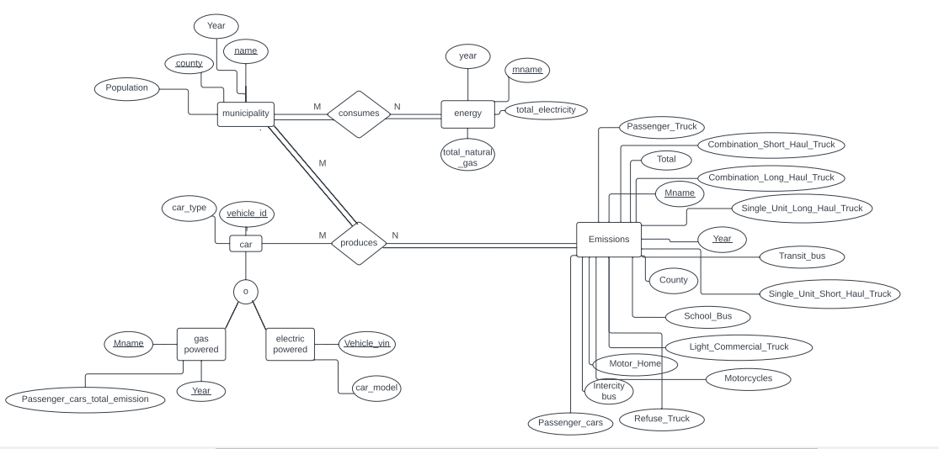

Schema:

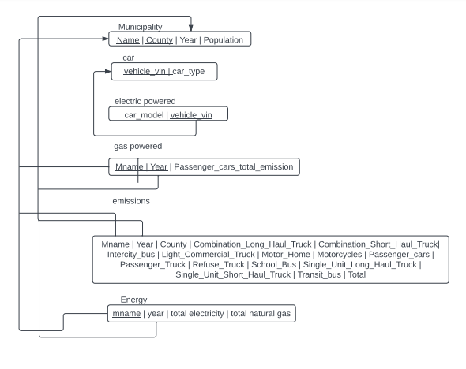

UML Use Cases:



**Database Model Explained:**

Relational databases organize data into rows and columns specifying attributes and relationships of entities. Entities are things in the world, attributes are traits about those entities, and relationships are how entities are connected. Relational databases are valuable because they explain how different entities are connected and organize information in an easy to read, tabular form. Our diagram contains 3 main entities- municipality, energy, and emissions. Car is broken down into the gas powered and electric powered subclasses. Our diagram shows the relationship between vehicles and emissions, as well as municipalities and energy consumption. Our database model focuses on these relationships and how emissions and energy compare from different vehicles of transportation. We designed the database in this way because our goals involve finding ways to reduce emissions and encourage people to switch to vehicles with less emissions. We are also looking for ways to reduce energy consumption because that also contributes to emissions. We want to encourage sustainability by giving users different ways of looking at how energy and vehicles impact emissions. Here are the calculations to estimate the rough size of our database.

File name: Vehicle_Miles_Traveled-On-Road_Vehicle_GHG_Emissions_Data_08.11.22

This is the VMT Data Section

Municipality: assuming that max string strength is 20 chars * 1 byte = 20 bytes

County name: assuming that max string length is 15 chars * 1 byte = 15 bytes

MPO: the string length is 5 = 5 chars * 1 byte = 5 bytes

Year: integer type so 4 bytes

The columns after Year includes all integer types: 14 * 4 bytes = 56 bytes

Total number of entries in the excel sheet: 1129 entries (this doesn't include the row for the column name and info): 1129

The rough size is: 1129 * (20 + 15 + 5 + 4 + 56) = 112,900 bytes

File name: Community-Scale_GHG_Emissions_08.22.2

This is the Community-Scale_GHG_Emissions - Metric Ton Carbon Dioxide Equivalent

Municipality: assuming that max string strength is 20 chars * 1 byte = 20 bytes

County name: assuming that max string length is 15 chars * 1 byte = 15 bytes

Year: integer type so 4 bytes

The columns after Year includes all integer types: 11 * 4 bytes = 44 bytes

The total number of entries in the excel sheet (this doesn't include the row for the column name and info): 1129

The rough size is: 1129 * (20 + 15 + 4 + 44) = 93, 707 bytes

File name: Electric_Vehicle_Ownership_Data_06.01.22

This is Electric Vehicle (EV) Ownership Data

Municipality: assuming that max string strength is 20 chars * 1 byte = 20 bytes

County name: assuming that max string length is 15 chars * 1 byte = 15 bytes

Year: integer type so 4 bytes

Total personal vehicles: can be integer type so 4 bytes

# of Evs: can be integer type so 4 bytes

% of Evs: can be integer type so 4 bytes

The rough size is: 1129 * (20 + 14 + 4 + 4+ 4 + 4) = 57, 579 bytes

The total size of the database is: 112,900 + 93,707 + 57,579 bytes = 264, 186 bytes

The estimated average number of searches is approximately 70 searches and the type of databases are numerical and string.

Use case I: Add a map to the website

Primary Actor: User

Goal in Context: Add a map of NJ and the user can press a certain municipality and it will link to another page that shows that area's facts and emission release/data specific to that area.

Trigger: User decides to view the map data on the website

Scenario:

1. User hovers over the map of New Jersey

2. User clicks on a specific municipality on the map to view data

3. User is transported to a new page that holds that area's emission data.

Use case II: Research Question button

Primary Actor: User

Goal in Context: Adding a button that says “Click for Research Questions” and when it is pressed, the website displays our 6 research questions as well as tables that display the information needed that answers the question, such as the corresponding tables and columns.

Trigger: User decides to view the research questions, to see which county generates the most emissions.

Scenario:

1. User clicks the “Click for Research Questions” button

2. User scrolls to the corresponding question.

3. User is shown data that depicts the total emissions of every county.

**Phase IV:**

**Demonstrate that all the relations in the relational schema are normalized to Boyce–Codd normal form (BCNF).**

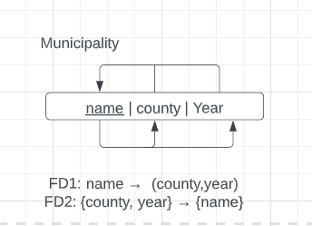

This relation is normalized to 1NF, 2NF and 3nf. In order to normalize this Relation to BCNF we need to make sure that every non-trivial functional dependency in the relation has a determinant that is a superkey of the relation. In the "Municipal" relation, the only non-trivial functional dependency is {name} → {county, year}, however {name} is not a superkey of the relation. In order to make the "Municipal" relation into BCNF, we need to break it down further:

R1(name, county)

R2(name, year, county)

In this decomposition, R1 has a candidate key {name}, and R2 has a candidate key {name, year}. The functional dependency {name} → {county, year} is now represented in both R1 and R2, ensuring that every non-trivial functional dependency has a determinant that is a candidate key.

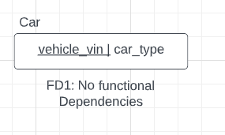

This relation has no functional dependencies and therefore cannot be broken down into BCNF.

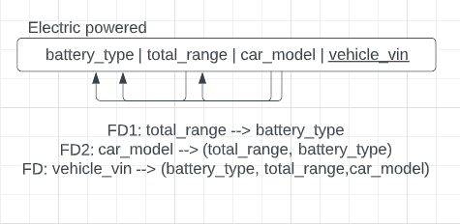

This relation is already in 1NF and 2NF but not in 3NF, in order to normalize this relation in 3NF, we must remove the transitive dependencies. {car_model} → {battery_type, total_range} is a transitive dependency which can be broken down into

R1: (vehicle_vin, car_model,total_range)

R2: (battery_type, total_range)

Since In each relation, every determinant is a candidate key, and there are no non-trivial functional dependencies among non-key attributes. Therefore, both relations satisfy the definition of BCNF.

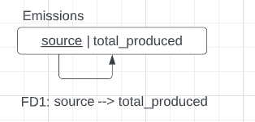

Since there is only one candidate key, which is the primary key {total_produced}, and there are no non-trivial functional dependencies in the relation meaning the relation is already in BCNF.

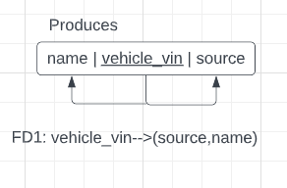

Since the "Produces" relation has only one functional dependency: {vehicle_vin} → {source, name}, and the primary key {vehicle_vin} determines all other attributes in the relation, the relation is already in BCNF.

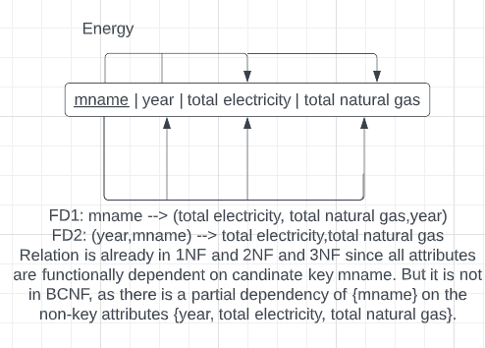

To bring the "Energy" relation to BCNF, we can decompose it into two smaller relations:

R1: (mname, year, total electricity)

R2:(mname, year, total natural gas)

Both of these relations have candidate keys {mname, year}. By breaking down the relation into these two smaller relations, we make sure that there are no partial dependencies, and each relation has a single candidate key.The relation is now in BCNF

**Define the different views (virtual tables) required. For each view list the data and transaction requirements. Give a few examples of queries, in English, to illustrate.**

1. List the emissions produced for all cars

CREATE VIEW EmissionsForAllCars AS

SELECT E.total_produced

FROM Emissions E

CROSS JOIN Car

WHERE Car.car_type = ‘gas powered’ AND ‘electric powered’

1. List how much electricity do cars alone produce in each municipality

CREATE VIEW ElectricityProducedInEachMunicipality AS

SELECT EY.total_electricty, M.mname

FROM Energy EY

JOIN Municipality M ON M.mname = EY.mname

CROSS JOIN Car

WHERE Car.car_type = electric powered’

**Design a complete set of SQL queries to satisfy the transaction requirements identified in the previous stages, using the relational schema and views defined in tasks 2 and 3 above.**

1. Which type of car generates the most amount of emissions?

SELECT C.car_type, Emissions.total_produced

FROM Car C

CROSS JOIN Emissions

WHERE Car.car_type = ‘gas powered’ AND ‘electric powered’

1. Which municipality generates the most amount of emissions?

SELECT M.name, MAX(Emissions.total_produced)

FROM Municipality M

CROSS JOIN Emissions

1. Which county generates the most amount of emissions?

SELECT M.name, Emissions.total_produced

FROM Municipality M

CROSS JOIN Emissions

1. Which electric car model generates the most amount of emissions?
2. Which gas car model generates the most amount of emissions?
3. From cars alone how much electricity does each municipality consume?

SELECT EY.total_electricty, M.mname

FROM Energy EY

JOIN Municipality M ON M.mname = EY.mname

CROSS JOIN Car

WHERE Car.car_type = electric powered’

1. From cars alone how much natural gas does each municipality consume?
2. Which source generates the most amount of emissions?
3. Which year generated the most emissions in each municipality?

**Appendix for Phase IV:**

In the process of producing our final end product, our group had to make changes. The following reflects the new changes that we made to our Phase IV.

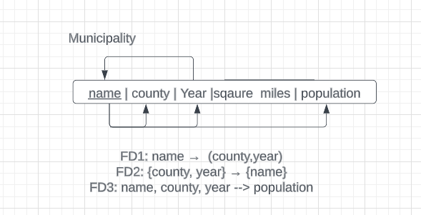

This relation is normalized to 1NF, 2NF and 3NF. In order to normalize this relation to BCNF we need to make sure that every non-trivial functional dependency in the relation has a determinant that is a superkey of the relation. In the "Municipality" relation, the non-trivial functional dependency is {name} → {county, year} and {name, county, year} → population; however {name} is not a superkey of the relation. In order to make the "Municipality" relation into BCNF, we need to break it down further:

R1(name, county)

R2(name, year, county)

R3 (name, county, year, population)

In this decomposition, R1 has a candidate key {name}, R2 has a candidate key {name, year}, and R3 has a candidate key {name, county, year, population}.The functional dependency {name} → {county, year} is now represented in both R1, R2, and R3 ensuring that every non-trivial functional dependency has a determinant that is a candidate key.

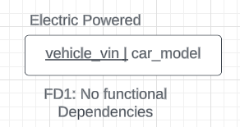

This relation has no functional dependencies and therefore cannot be broken down into BCNF.

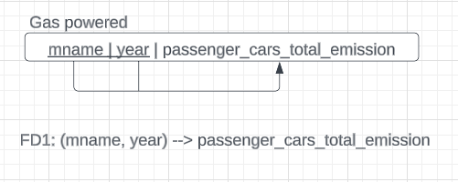

This relation’s functional dependency is {mname, year} → {passenger_cars_total_emission}. The primary key in this relation is a composite primary key which are name and year. This is used to determine the other attribute in the relation. This relation is already in BCNF.

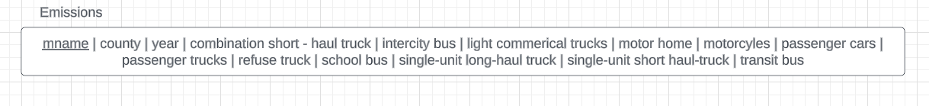

This relation has no functional dependencies and therefore cannot be broken down into BCNF.

**Define the different views (virtual tables) required. For each view list the data and transaction requirements. Give a few examples of queries, in English, to illustrate.**

CREATE VIEW map

AS SELECT total_emissions.Mname, total_emissions.County,

total_emissions.Year, total_emissions.Passenger_cars,

total_emissions.Total, energy.Total_electricity, energy.Total_natural_gas

FROM total_emissions JOIN energy ON total_emissions.Mname = energy.Mname

AND total_emissions.county = energy.county AND total_emissions.year = energy.year;

**Design a complete set of SQL queries to satisfy the transaction requirements identified in the previous stages, using the relational schema and views defined in tasks 2 and 3 above.**

Which type of gas powered vehicle generates the most amount of emissions?

SELECT SUM(combination_long_haul_truck), SUM (combination_short_haul_truck), SUM(intercity_bus), SUM(light_commercial_truck), SUM(motor_home), SUM(motorcycles), SUM(passenger_cars), SUM(passenger_truck), SUM(refuse_truck), SUM(school_bus), SUM(single_unit_long_haul_truck), SUM(single_unit_short_haul_truck), SUM(transit_bus) FROM total_emissions WHERE year >= 2019;

Which county generates the most amount of emissions?

SELECT County, SUM(Total) AS Total_emissions FROM Total_emissions GROUP BY County;

Which year generated the most emissions in each municipality?

SELECT M.Name, M.County, TE.Year, TE.Total FROM Total_emissions TE JOIN municipality M ON TE.Mname = M.Name AND TE.County = M.County AND TE.Year = M.Year WHERE TE.Year IN (2015, 2017, 2019, 2020) AND TE.Total = (SELECT MAX(Total) FROM Total_emissions WHERE Mname = TE.Mname AND County = TE.County AND Year = TE.Year);

How many EV vehicles does each county have?

SELECT county, SUM(EVs) AS num_evs FROM vehicles WHERE year = 2020 GROUP BY county ORDER BY num_evs DESC;

How many gas cars does each county have?

SELECT county, SUM(Gas) AS num_gas FROM vehicles WHERE year = 2020 GROUP BY county ORDER BY num_gas DESC;

What are the total number of vehicles does each municipality have in years 2015 and 2020?

SELECT Name, County, Year, vehicles FROM vehicles WHERE Year = 2020 ORDER BY vehicles DESC;

**Phase V (a):**

**SQL Tables (DDL):**

CREATE TABLE municipality (

Name VARCHAR(255),

County VARCHAR(255),

Year INT,

Square_Miles FLOAT(1),

Population INT,

PRIMARY KEY(Name, County, Year)

)

;

CREATE TABLE vehicles (

Name VARCHAR(255),

County VARCHAR(255),

Year INT,

Vehicles INT,

EVs INT,

Gas INT

)

;

CREATE TABLE total_emissions (

Mname VARCHAR(255),

County VARCHAR(255),

Year INT,

Combination_Long_Haul_Truck bigint,

Combination_Short_Haul_Truck bigint,

Intercity_Bus BIGINT,

Light_Commercial_Truck BIGINT,

Motor_Home BIGINT,

Motorcycles bigint,

Passenger_cars bigint,

Passenger_Truck bigint,

Refuse_Truck bigint,

School_Bus bigint,

Single_Unit_Long_Haul_Truck bigint,

Single_Unit_Short_Haul_Truck bigint,

Transit_bus bigint,

Total bigint,

PRIMARY KEY (Mname, County, Year)

)

;

CREATE TABLE gas_car_emissions (

Mname VARCHAR(255),

County VARCHAR(255),

Year INT,

Car_emissions FLOAT(2),

PRIMARY KEY (Mname, County, Year)

)

;

CREATE TABLE energy (

Mname VARCHAR(255),

County VARCHAR(255),

Year INT,

Total_electricity bigINT,

Total_natural_gas bigINT,

PRIMARY KEY(Mname, County, Year)

)

;

**Populate tables:**

\COPY municipality FROM 'Municipality.csv' DELIMITER ',' CSV HEADER;

\COPY vehicles FROM 'Vehicles.csv' DELIMITER ',' CSV HEADER;

\COPY total_emissions FROM 'Emissions.csv' DELIMITER ',' CSV HEADER;

\COPY gas_car_emissions FROM 'Gas_car_emissions.csv' DELIMITER ',' CSV HEADER;

\COPY energy FROM 'Energy.csv' DELIMITER ',' CSV HEADER;

**Create view for map:**

CREATE VIEW map

AS SELECT total_emissions.Mname, total_emissions.County,

total_emissions.Year, total_emissions.Passenger_cars,

total_emissions.Total, energy.Total_electricity, energy.Total_natural_gas

FROM total_emissions JOIN energy ON total_emissions.Mname = energy.Mname

AND total_emissions.county = energy.county AND total_emissions.year = energy.year;

**SQL Queries (DML Commands):**

Which type of gas powered vehicle generates the most amount of emissions?

SELECT SUM(combination_long_haul_truck), SUM (combination_short_haul_truck), SUM(intercity_bus), SUM(light_commercial_truck), SUM(motor_home), SUM(motorcycles), SUM(passenger_cars), SUM(passenger_truck), SUM(refuse_truck), SUM(school_bus), SUM(single_unit_long_haul_truck), SUM(single_unit_short_haul_truck), SUM(transit_bus) FROM total_emissions WHERE year >= 2019;

Which county generates the most amount of emissions?

SELECT County, SUM(Total) AS Total_emissions FROM Total_emissions GROUP BY County;

Which year generated the most emissions in each municipality?

SELECT M.Name, M.County, TE.Year, TE.Total FROM Total_emissions TE JOIN municipality M ON TE.Mname = M.Name AND TE.County = M.County AND TE.Year = M.Year WHERE TE.Year IN (2015, 2017, 2019, 2020) AND TE.Total = (SELECT MAX(Total) FROM Total_emissions WHERE Mname = TE.Mname AND County = TE.County AND Year = TE.Year);

How many EV vehicles does each county have?

SELECT county, SUM(EVs) AS num_evs FROM vehicles WHERE year = 2020 GROUP BY county ORDER BY num_evs DESC;

How many gas cars does each county have?

SELECT county, SUM(Gas) AS num_gas FROM vehicles WHERE year = 2020 GROUP BY county ORDER BY num_gas DESC;

What are the total number of vehicles does each municipality have in years 2015 and 2020?

SELECT Name, County, Year, vehicles FROM vehicles WHERE Year = 2020 ORDER BY vehicles DESC;

**DDL Set Up:**

createdb proj7

psql proj7

\i DDLSetup.sql

\i DMLQueries.sql

\s Setup

**Phase IV:**

<https://drive.google.com/file/d/1ypr21dEE79JNxJE-cjwUOG_222NcxvGE/view?usp=sharing>

**The Proposal:**

Our initial research topic was examining the cause of high greenhouse gas emissions in the state of New Jersey. The increase in greenhouse gas emissions rely on many external factors, so our group chose to focus on exploring gas cars and the number of emissions that they produce, and whether increased usage of electric vehicles would help significantly reduce greenhouse gas emissions caused by gas cars.

After examining the data provided by the Sustainable Jersey Database containing emissions produced by gas-powered vehicles as well as EV ownership in the state of New Jersey, our group had concluded that the best way to reduce greenhouse gas emissions from on-road vehicles is to advocate for more usage of electric vehicles. While examining the data provided, we noticed that gas-powered passenger vehicles were producing the most emissions out of all types of gas-powered vehicles on the road. The emissions produced by passenger vehicles amounted to 45,019,685,000 tons in our table. This is expected, since many New Jersey residents frequently use cars to travel to work or other places. In addition, the emissions produced by on road vehicles in New Jersey have only increased from 2015 to 2020 in most municipalities. When examining electric vehicle ownership in each county in New Jersey, our group has noticed that the number of electric vehicles owned by residents in each county is significantly less than the number of gas cars owned. For example, Bergen County holds the highest number of electric vehicles at 4958. However, the number of gas vehicles owned in that same county is much higher, at 571,131 total cars. Therefore, we concluded that an increase in electrical vehicle ownership is necessary in order to reduce the amount of greenhouse gas emissions coming from gas-powered vehicles.

However, many people may be hesitant to make the switch to electric vehicles, and there are many reasons for this. For one, electric cars are much more expensive than gas-powered cars due to the costs of materials needed for manufacturing as well as battery costs. In addition, there is a lack of charging infrastructure for electric vehicles. Not many individuals live in areas where they can reliably charge their cars, which leaves them the option of charging at public EV charging stations, which are difficult to find. There are also concerns associated with the limited range of EVs as well as the battery life. Most of today’s electric vehicles can go about 250 miles on a charge, so EV owners can “get away with charging once or twice a week, much like going to the gas station once a week,” (Loveday 10). However, if a person wants to travel across the country, especially through rural areas, it might be difficult to find a place to charge before the battery runs out. As for the battery lifespan, there may be concerns as to the environmental damage that disposing of EV batteries could cause.

Therefore, a detailed plan must be devised to account for such concerns and improve municipal sustainability through increasing the use of electric vehicles. There will be various steps to this plan:

1. Provide EV charging stations: Municipalities should install public EV charging stations in their parking lots, streets, and public areas to make it more convenient for residents and visitors to charge their EVs.
2. Encourage the transition from gas-powered to EVs: Municipalities will offer incentives such as tax breaks or rebates to residents who purchase or lease an EV. They can also promote EV use through public education campaigns and seek out the possibilities of partnering with local businesses to encourage the transition from gas-powered to EVs.
3. Create EV-friendly policies: Municipalities will create policies that support EV use, such as reserved parking. They should also require residential and commercial buildings to have charging stations.
4. Encourage Research and Development: Governments should invest in the research and development of new technologies and new types of materials such as a new battery design to account for concerns in short ranges of EVs as well as the disposing of batteries once they’ve completed their lifespan.

The positive ethical implication of promoting the use of EVs begins with reducing greenhouse gas emissions. Also, it creates sustainable transportation options, which reduces our reliance on fossil fuels. Lastly, it can promote economic growth by creating jobs in the EV industry.

However, there are also negative ethical implications to consider. Starting with the ethical sourcing of materials used in EV batteries such as cobalt and/or lithium because they are toxic and can contaminate water supplies and ecosystems if they leach out of landfills. Additionally, the possible cost of implementing and maintaining the infrastructure needed to support EV use may be passed onto residents through taxes or fees. Finally, the increased demand for electricity may put tension on the electric grid, needing larger infrastructure investments or leading to higher electricity prices. Ethical concerns associated with battery design can be addressed through further research and development into more sustainable materials used in the creation of EV batteries as stated previously in our plan. To account for increased tension in the electrical grid, electrical charging stations can be placed strategically and systems can be put in place to account for peak time electricity. A delayed home charging system allows those with charging infrastructure in their home to set a charging cycle that takes advantage of off-peak hours to charge their EVs, reducing tension on the electric grid.

The positive ethical implications far outweigh the possible negative implications, which is why it is worth promoting EV use. The potential to reduce greenhouse gas emissions and promote sustainable transportation is worth the risk. With proper planning, the positive ethical implications will be proven.

**WORKS CITED:**

Chandler, David L. “Minimizing Electric Vehicles' Impact on the Grid.” MIT News | Massachusetts Institute of Technology, 15 Mar. 2023, https://news.mit.edu/2023/minimizing-electric-vehicles-impact-grid-0315.

Loveday, Steven. “Here's Why People Don't Buy Electric Cars (and Why They're Wrong).” U.S News &amp; World Report, 28 Nov. 2022, https://cars.usnews.com/cars-trucks/advice/why-people-dont-buy-electric-cars.

Slayton, Nicholas. “7 Reasons Why Drivers Are Not Ready to Switch to Electric Vehicles (Yet).” Yahoo! Finance, Yahoo!, 31 May 2022, https://finance.yahoo.com/news/7-reasons-why-drivers-not-222800540.html.